Name: DURKASRI
ROLL NO: 240701132

EXP : 06 RAD Model (Spotify Clone – Listenify)
AIM
To simulate the lifecycle stages of UI design using the Rapid Application Development (RAD) model and develop an interactive prototype using Figma.

DESCRIPTION
RAD (Rapid Application Development) focuses on quick development and continuous user feedback. In this experiment, a music streaming application UI (Listenify – Spotify Clone) was designed and prototyped using Figma.

🧩 PHASE 1: REQUIREMENTS PLANNING
- Identified main features of the application:

  - Home page with search option

  - Song categories (Meditation, Happy, Travel)

  - Song description page

  - Playlist section

- Defined user actions:

  - Searching songs
  - Browsing categories

  - Viewing song details

  - Managing playlists

🎨 PHASE 2: USER DESIGN
- Created wireframes and UI screens in Figma:

  - Home Screen

  - Song Page

  - Song Description Page

  - Playlist Page

- Designed layouts with buttons, images, and navigation elements

- Added basic interactions to simulate navigation between screens

⚙ PHASE 3: CONSTRUCTION
- Developed an interactive prototype using Figma

- Linked all screens using clickable buttons

- Tested navigation and user flow

- Improved UI based on feedback and usability

🚀 PHASE 4: CUTOVER
- Finalized the prototype design
- Shared the project using Figma link

- Prepared the interface for demonstration

🖼 OUTPUT
The UI prototype includes multiple screens such as Home, Song Page, Song Description, and Playlist for the Listenify music app.

✅ RESULT
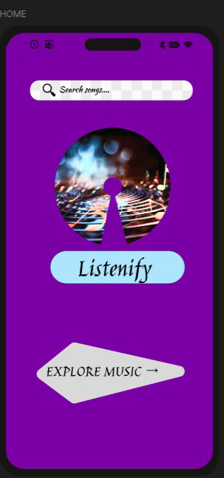
Thus, the UI design of a music streaming application (Listenify) was successfully developed using the RAD model and implemented using Figma.
